# Scope of Work

## Portal Installation and configuration

We will build an Enterprise Portal Access for The Client(Whose Business needs a Multimedia Content Management Solution).

The whole Portal structure will be configured in SharePoint, where all the page layouts, templates and sitemaps will be created centrally. The Client(Whose Business needs a Multimedia Content Management Solution) may create many sub sites using existing templates.

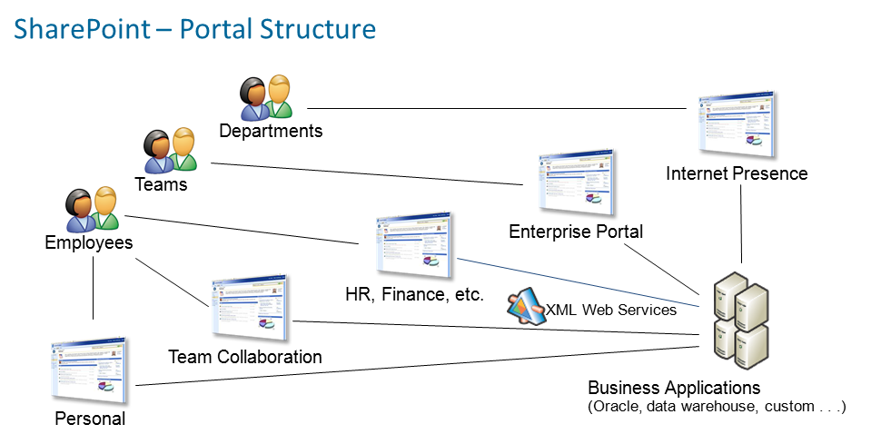

Portal Structure

## Information Services

We will configure SharePoint content management services to allow adding and managing Portal content and structure for The Client(Whose Business needs a Multimedia Content Management Solution) EJIS.

The Client(Whose Business needs a Multimedia Content Management Solution) content authors can create content and lists immediately on the fly for any information to be published to The Client(Whose Business needs a Multimedia Content Management Solution) Portal users. The list items will automatically get crawled by The Client(Whose Business needs a Multimedia Content Management Solution) search engine. The lists are modifiable for future update.

## Portal User Customer Profile

We will configure SharePoint Profile store and authentication provider to be integrated with Active Directory or to connect to the preferred user database to manage users.

## Video Retrieval and Playback Services

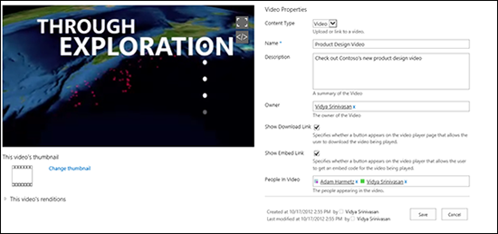

The portal will have playback for the videos stored in SharePoint and it has the features of play, stop, rewind for the video, while some other features like editing/cutting the video, zooming and integrity will be provided through a link to the recording application within our solution.

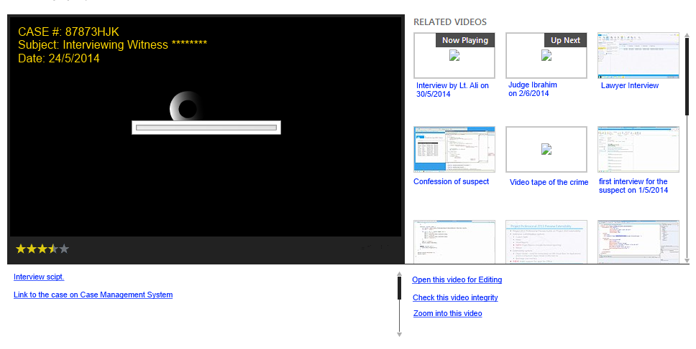

## Schedule Management Services

In order to provide the user with a centralized interface, the scheduling will be done from the video conferencing provided solution while it will be linked from the portal to allow the users to easily open it from The Client(Whose Business needs a Multimedia Content Management Solution) EJIS portal.

## Support/Help Services

We will create a help and support sub site in The Client(Whose Business needs a Multimedia Content Management Solution) Portal Access where it will have all the information related to the solution like:

* User Documentation
* Training Materials
* FAQ

### Monitoring Services

The Client(Whose Business needs a Multimedia Content Management Solution) Portal Access will integrate with the provided monitoring application through XML web services and will list the monitoring information retrieved from this web service. One monitoring dashboard will be created showing information retrieved from the monitoring application.

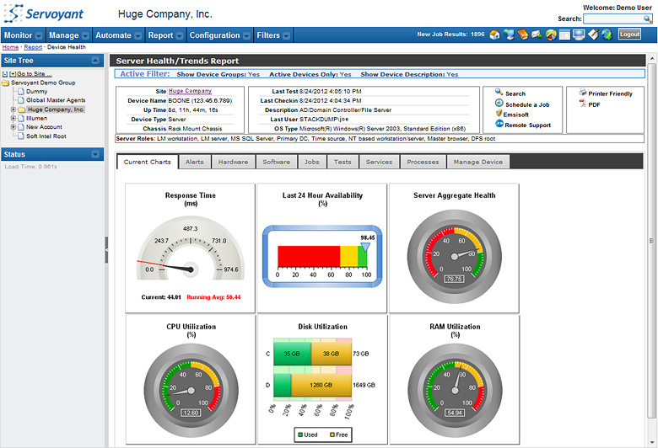

### Tickets and Resolution

We will create a tickets list and a SharePoint custom list to enable creating tickets with audit trail and status of its resolution. The tickets will have the basic tickets information like (Ticket ID, Initiator, Creation Date, Problem Description, classification, severity, status, resolution date) and the user can attach any documents to his ticket.

### Agent Live Chat

We will provide this through Microsoft Lync to enable the presence of the Agents in the support team and the user can automatically ping them from the portal and initiate a chat.

### Support Contacts list

We will create a SharePoint Contacts lists to have all the support agents contact information placed in one central location under the support help service sub site in The Client(Whose Business needs a Multimedia Content Management Solution) EJIS Portal.

## Case Management System Services

We will integrate with The Client(Whose Business needs a Multimedia Content Management Solution) Case Management System through XML web services provided from The Client(Whose Business needs a Multimedia Content Management Solution) current integration middleware that is connected in SharePoint using SharePoint Connectivity Services where we’ll create a custom list in The Client(Whose Business needs a Multimedia Content Management Solution) Portal Access to have the case information and users can access it based on their privileges.

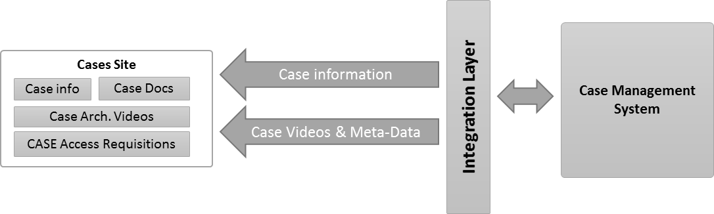

We will create a custom video library to allow archiving the videos with its meta-data having the case link in this meta-data, where this link will be stored once the video conferencing system is writing/saving the videos in The Client(Whose Business needs a Multimedia Content Management Solution) EJIS Portal.

We will create a custom list for users who don’t have access to the case information to request access to the case information, where the administration will look into his request and validate it and accordingly he’ll manually give him access to the case details in Portal and/or in case management system based on his request.

## User Administration Services

By default SharePoint is automatically integrated with Active Directory that is supported with any Identity Management for users provisioning and de-provisioning, while if The Client(Whose Business needs a Multimedia Content Management Solution) to connect to different Profile Stores like HR system or Case Management system then we assume those systems are already configured with Identity Management and therefore the portal will use the same roles in that system.

In case The Client(Whose Business needs a Multimedia Content Management Solution) doesn’t have an Identity Management solution that we’ll implement this using Microsoft Forefront Identity Management which provides the following:

* **User Management**: FIM delivers tools for more efficient user provisioning and de-provisioning. These include:
  + Improved tools for user provisioning.
  + Integrated provisioning of identities, credentials, and resources. We can use FIM to create policies that seamlessly provision and de-provision the appropriate accounts, resources, and credentials
  + Self-service profile management for users. We can set policies to enable end users to update profile information, such as their phone numbers, and to require approvals for and notifications of user-generated changes. End users can use these pages to search for other users as a white pages application
  + Moving users and providing them with all the required access rules based on rules that will govern users management through the different systems available.
* **Empowering People**: FIM puts the right tools in the hands of end users, IT professionals, and developers to increase their productivity and to lower help desk and other costs
  + Increases end-user productivity through self-help tools integrated into Office and Windows®. Without calling the help desk, users can reset a password or smart card PIN. FIM portal also provides users with capabilities such as update their own profile, search for co-workers.
  + Increases developer productivity through extensibility. Developers can access Web Services–based APIs and .NET to customize FIM functionality through the familiar Microsoft Visual Studio® and .NET development environments.
* **Delivering Agility and Efficiency**: Through automation, self-service, and rich extensibility, FIM reduces the high costs and risk often associated with identity management
  + FIM 2010 reduces costs through automation and self-service. It automates the management of users, groups, and other resources based on business policy, and delivers tools to help end users manage their own identity information in the web based interface
  + Integrates the heterogeneous identity infrastructure of the enterprise. FIM provides a single place to manage identities across a broad range of leading network operating systems, e-mail and collaboration tools, databases, directories, and applications.
  + FIM 2010 maximizes existing investments. FIM makes it easier to manage identities across the existing infrastructure including Active Directory® Domain Services, Microsoft Exchange, and Active Directory Certificate Services.
* **Increasing Security and Compliance**: FIM 2010 improves security and compliance, with management and auditing across identities, credentials, and resources.
  + FIM 2010 secures the enterprise by integrating identity, credential, and access management across the organization. FIM enables the IT team to use a single, unified policy management system to manage users, their access and resources, and their credentials (including strong credentials).
  + Enables system audits to reduce the risk of noncompliance. Policy management tools enable business owners and IT to audit business rules and events processed by FIM, and to enforce those rules that support compliance automatically
  + Integrated management tools allow organizations to better enjoy the security benefits of strong authentication

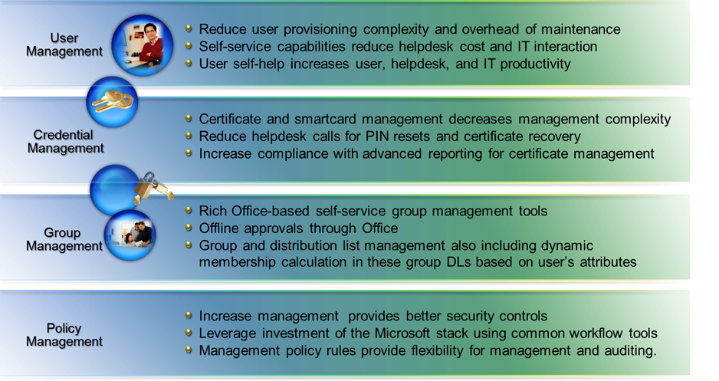

**Figure 1: FIM 2010 Benefits**

Apart from the above mentioned benefits, the following rich features of FIM 2010 will deliver the requisite agility to The Client(Whose Business needs a Multimedia Content Management Solution) EJIS Portal.

* **Policy Management**: FIM establishes a framework for automating and integrating identity management so all enterprise systems use the same set of policies. This is accomplished through:
  + Centralized authoring, enforcement, and auditing of policies. IT administrators can manage policies that govern users and groups with menu-driven controls, thereby reducing the risk of noncompliance
  + Extensible Windows Workflow Foundation–based workflows. The IT team can use these to approve account creation and delegate tasks and other such actions, and can easily extend them to deliver complex custom workflows
* **Credential Management**: FIM integrates the management of credentials for both administrators and end users through:
  + Credential lifecycle management integrated with provisioning. IT professionals can manage the process of provisioning accounts and credentials using a single tool
  + Centralized management of multiple credentials such as Microsoft and third-party certificate authorities
  + Password synchronization across systems, which enables simplified sign-on
  + Intuitive experiences built into the Windows desktop logon so users can reset their own passwords and provision their own smart cards
* **Group Management**: FIM group management helps increase end-user productivity, frees IT from repetitive identity management tasks, and provides better security and compliance through:
  + Self-service group management tools integrated into Office and SharePoint. These enable users to manage group membership requests using familiar applications and include enabling requests offline
  + Automated dynamic updates of group and distribution groups. We can use FIM management tools to create policies that keep groups and distribution groups up to date automatically

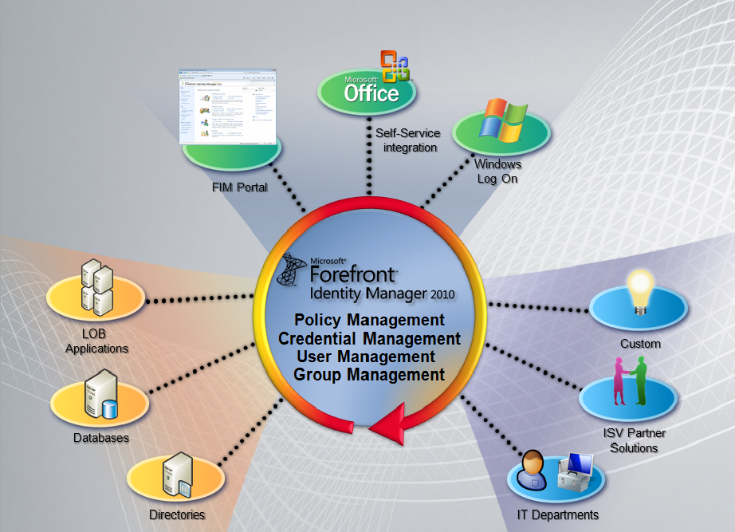

**Figure 2: Forefront Identity Manager (FIM) 2010**

## Video Administration Services

We will implement and configure ECM for The Client(Whose Business needs a Multimedia Content Management Solution) Portal Access to allow administrating archived videos. We will create with up to 25 Video File Content Types (Interview, Witness Confession, Investigation, Court Sessions, etc..) meta-data and attributes in the ECM with up to 10 meta-data fields that will be entered by indexes.

Videos Administration and ECM features in SharePoint allows Retention and Disposal for videos and content through Records Management features in SharePoint.

Netways will configure The Client(Whose Business needs a Multimedia Content Management Solution) EJIS general Taxonomy for the Videos ECM and will enable search through that taxonomy.

Netways will configure the Security model for the total ECM solution.

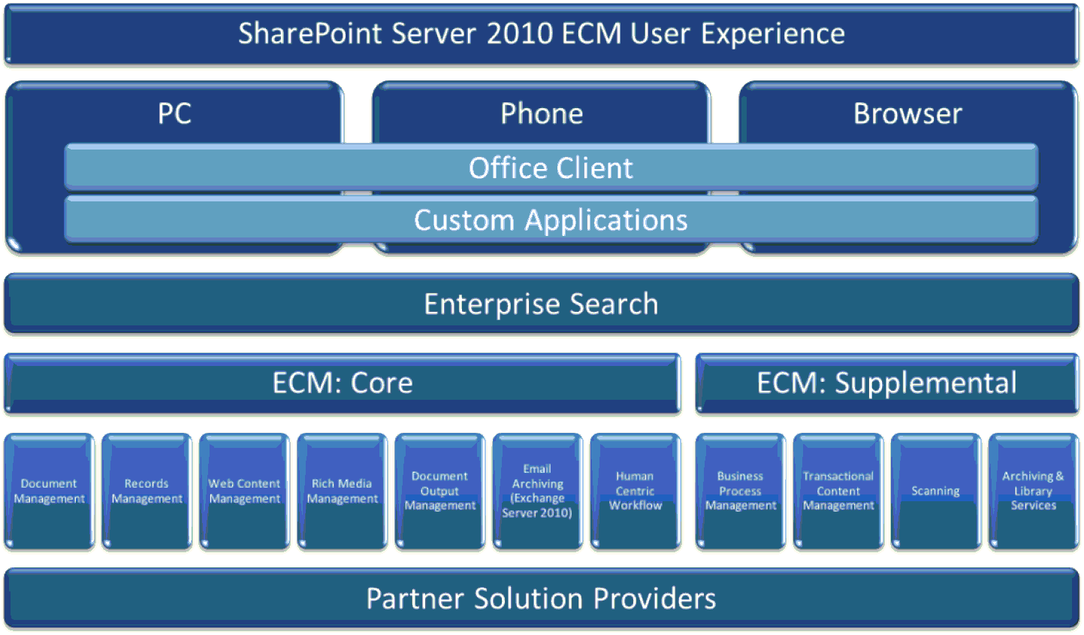

Microsoft® SharePoint delivers a platform approach that can manage unstructured data and address many, if not all, of the deployment blockers with:

* **Tools that enable and encourage user interaction.** If end users resist, then the ECM solution will fail. SharePoint provides automated and convenient document tagging and metadata management.
* **Architecture and tools that provide security and help manage compliance and policies**. All unmanaged content is a potential risk, and new types of unmanaged content are appearing every day (Facebook status updates, blogs, wikis, documents stored in the “cloud” - i.e., hosted Internet services such as SkyDrive-, etc.).
* **Guidance and technology that helps avoid high costs of ECM point solutions**, especially where not needed – and integrate ECM information silos. Individual point solutions provide deep management and security in one or two areas, but can be expensive to integrate and maintain. In addition, they are typically only used by a subset of employees.

## Portal Touch Version

We will create another version of The Client(Whose Business needs a Multimedia Content Management Solution) Portal Access that is optimized for display on different devices. By defining different channels and associating different devices with them, we’ll create for The Client(Whose Business needs a Multimedia Content Management Solution) Portal Access a different master pages to optimize how the website is presented to the user.

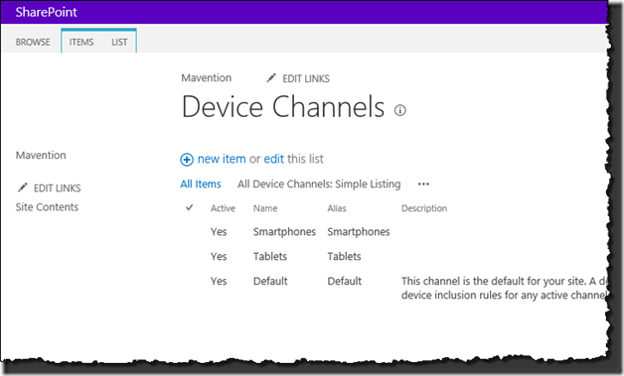

Whereas responsive web design uses a device’s screen size to determine the presentation layer, device channels in SharePoint 2013 use the identity of the browser on the particular device to decide which presentation style to use.

## Training

We will provide The Client(Whose Business needs a Multimedia Content Management Solution) Technical and User project team with Skill transfer so that they can develop and establish well skilled groups to continuously enhance and improve The Client(Whose Business needs a Multimedia Content Management Solution) portal components. All the below training sessions will be provided by our Consultants at The Client(Whose Business needs a Multimedia Content Management Solution) location in Abu Dhabi and one time only. The training course maximum attendees and it is limited to 15 employees (following the train the trainer approach).

### SharePoint Admin training (With Hands on Labs ) - 3 Days

The Course Modules are:

* Module 1: The Role of the Site Owner
* Module 2: SharePoint Review
* Module 3: Using and Customizing Lists
* Module 4: Creating Forms Libraries
* Module 5: Creating Basic Web Pages
* Module 6: Sites and Workspaces
* Module 7: Users and Groups
* Module 8: Site Activity
* Module 9: Using SharePoint Designer (Optional Module)

### SharePoint Administration Advance Training (Operations Hands on Labs) - 5 Days

The Course modules are:

* Introduction
* Module 2: Overview
* Module 3: Installing
* Module 4: SharePoint Architecture
* Module 5: StsAdm
* Module 6: SharePoint Services
* Module 7: Power Shell
* Module 8: General Operations Tasks
* Module 9: Information Right Management
* Module 10: Anti-Virus
* Module 11: Information Management Policy
* Module 12: Single Sign On
* Module 13: Logging Settings
* Module 14: Usage Analysis Processing
* Module 15: Content Deployment
* Module 16: Backup Restore
* Module 17: Timer Jobs
* Module 18: Shared Service Provider
* Module 19: Application Security
* Module 20: InfoPath Services
* Module 21: Business Data Catalog
* Module 22: Search
* Module 23: Excel Services
* Module 24: User Profiles My Sites
* Module 25: Performance Optimization
* Module 26: Updating The Farm

### SharePoint Development training (Dev Workshop) - 5 Days

The Course Modules are:

* Module 1: Overview
* Module 2: Document Policies
* Module 3: Records Management
* Module 4: Content Management
* Module 5: InfoPath Forms Services
* Module 6: Excel Services
* Module 7: Business Data Catalog
* Module 8: Business Intelligence
* Module 9: Document Converters
* Module 10: User Profiles
* Module 11: Audiences
* Module 12: Search

### SharePoint Development Advance Course (Dev boot camp) - 5 Days

The Course Modules are:

* Module 1: Overview
* Module 2: Custom Authentication
* Module 3: SharePoint Permissions
* Module 4: In-Browser Customization
* Module 5: Basic SharePoint Designer
* Module 6: Advanced SharePoint Designer
* Module 7: Content Types
* Module 8: Site Definitions
* Module 9: Features
* Module 10: Web Services API
* Module 11: Web Part Development
* Module 12: Client Side Scripts / AJAX\
* Module 13: Object Model
* Module 14: Custom Field Types
* Module 15: SharePoint Events / Timer Jobs
* Module 16: Shared Services
* Module 17: Workflows (SP Designer)
* Module 18: Workflows (Visual Studio)
* Module 19: ASP.NET Localization
* Module 20: SharePoint/Microsoft FrontPage RPC
* Module 21: Excel Services
* Module 22: Business Data Catalog
* Module 23: Business Intelligence
* Module 24: Upgrading WSS 2.0 to 3.0

### Power User Training (Site Owners with Hands on Labs) - 2 Days

The Course Modules are:

* Module 1: The Role of the Site Owner
* Module 2: SharePoint Review
* Module 3: Using and Customizing Lists
* Module 4: Creating Forms Libraries
* Module 5: Creating Web Pages
* Module 6: Sites and Workspaces
* Module 7: Users and Groups
* Module 8: Site Activity

### End User (train the trainer with HOLs) - 3 Days

The Course Modules are:

* Module 1: Overview
* Module 2: SharePoint Introduction
* Module 3: Basic Team Site
* Module 4: Lists
* Module 5: List Management
* Module 6: Permissions
* Module 7: WSS Site Definitions
* Module 8: SharePoint Site Definitions
* Module 9: Office Integration
* Module 10: Workflows
* Module 11: My Site
* Module 12: Basic Site Administration
* Module 13: Site Customization